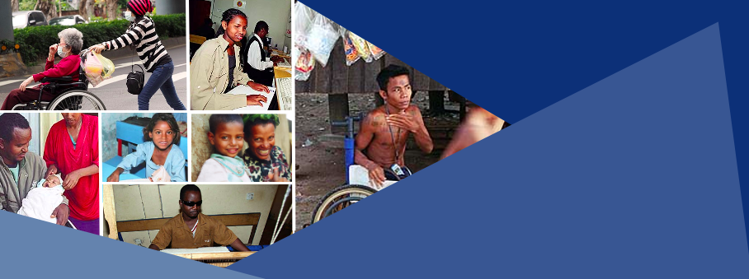

Social Protection and Inclusion of Persons With Disabilities
SOCIAL PROTECTION AND INCLUSION OF PERSONS WITH DISABILITIES

Short course (Online-2021)
Bonn-Rhein-Sieg University of Applied Science in cooperation with the International Labour Organization, UNICEF, UN Partnership on the Rights of Persons with Disabilities

1st Session May 15th - July 31st 2021
2nd Session July 15th - September 30th 2021
Background
Persons with disabilities, which comprise 15% of the world’s population, are more likely to be poor, to face catastrophic health expenditures, and to have lower levels of education and economic participation. Barriers to employment and disability-related costs contribute greatly to their higher vulnerability. Social protection is therefore critical for their inclusion, empowerment and sustainable escape from poverty. While in high income countries social protection systems provide a quasi-universal coverage, less than 20% of persons with significant disabilities in low- and middle-income countries (LMICs) have to access disability related benefits.
The COVID-19 crisis has magnified those barriers and highlighted the limited capacities of most LMICs’ social protection systems to provide fast relief to persons with disabilities.
To mitigate the risk of further marginalisation of persons with disabilities and their families, an inclusive response and recovery requires additional and continued investments in developing universal and inclusive social protection systems, including floors.
Objectives
The course aims at developing capacity of participants to design, advice or advocate for inclusive social protection systems and schemes fostering empowerment of persons with disabilities across the life cycle.
By the end of the course, participants will be able to:
- Develop a rationale for reforms towards inclusive social protection systems;
- Identify barriers undermining access of persons with disabilities to social protection schemes/programs;
- Analyze social protection systems’ capacities to provide adequate support to persons with disabilities;
- Understand the combination of different types of programs and schemes that can contribute to income security, access to health care and coverage of disability-related costs across the life cycle;
- Develop context relevant strategies to progressively achieve universal and comprehensive social protection for empowerment of persons with disabilities;
- Support meaningful participation of persons with disabilities in social protection related processes.

Who attends this course? (limited to 40 participants for 2021 sessions)
Government disability and social protection focal points, leaders and staff of organizations of persons with disabilities, social protection specialists, social inclusion specialists. The second session is also offered as a specialization for students enrolled in the Master: Analysis and Design of Social Protection Systems.
Who are the trainers?
Trainers include senior disability or social protection specialists from UNICEF, ILO and Center for Inclusive Policy.
Certification
All participants who successfully complete all the assignments (submission of 3 short written assignments and 1 final policy paper) will receive a Certificate from the Bonn Rhein Sieg University of Applied Science.
Fees
Free: The course is sponsored in 2021 by the ILO with UNPRPD funds, with additional in kind-contributions from UNICEF (Norway partnership) and the Centre for Inclusive Policy.
Duration
4 weeks online and independent work (200 hours in total over 8 weeks)
Pre-requisites
Relevant work experience in the field of disability inclusion and/or social protection
Bachelor degree in social sciences, economics, law, development studies or equivalent preferred, but extensive work experience will be taken into account
Language
English (Sign Language interpretation provided on demand for video conferences)
Outline of the course
The course is composed of 4 modules
- Module 1. Disability, inequalities, and inclusion: what does the data say?
  - Disability in data collection and analysis
  - Evidence about disability, inequality, intersectionality, and poverty
  - Impact of disability related costs
- Module 2. Towards inclusive social protection for empowerment of persons with disabilities
  - Rationale for inclusive social protection for persons with disabilities
  - Ensuring access across social protection programs across the life cycle
  - Ensuring income security and coverage of health care and addressing disability related costs
  - Cash, in kind support and services combination
  - Political economy of social protection reforms
- Module 3. Disability assessment, eligibility determination and case management
  - Disability identification, assessment, and determination
  - Disability /equal opportunity card and registry
  - Factoring disability in poverty targeting and means tests
  - Linkage to social protection information systems
- Module 4. Life cycle approach and inclusive social protection systems
  - Children with disabilities
  - Working age adults with disabilities
  - Older persons with disabilities
All assignments will be inter-connected and will allow participants to build step-by-step a reform proposal for more and better social protection in support to inclusion of persons with disabilities across the life cycle.
Application
Please apply until May 7th 2021 for the May-July session and 16th June for the July-September session
Download application form here

ILO, UNICEF, UNPRPD, 2020 Disability Inclusive Social Protection Response to the COVID-19 crisis
ILO 2019. Measuring financing gaps in social protection for achieving SDG target 1.3 global estimates and strategies for developing countries

